Docker for Windows 10

1. Sign up for Docker and download the docker from <https://hub.docker.com/editions/community/docker-ce-desktop-windows> (get the Window(Stable) version )

If you have unsupported environment then check the below link,

<https://docs.docker.com/toolbox/toolbox_install_windows/>

1. By default Hyper-V is disabled. After downloading the docker click on the installer exe and run the installation. Once the installation is completed, it will sign-out. You will get a notification from docker to enable Hyper-V, once you click on the enable the system restarts and you can see the following in windows features,

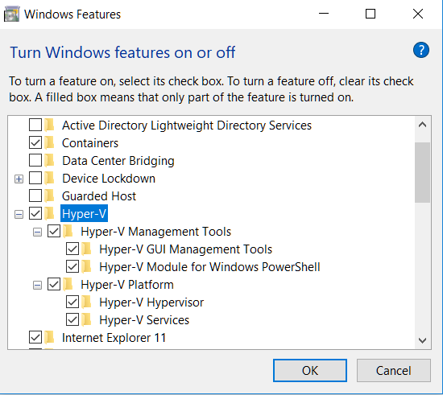

1. Docker still faces issue to start as the virtualization was disabled.

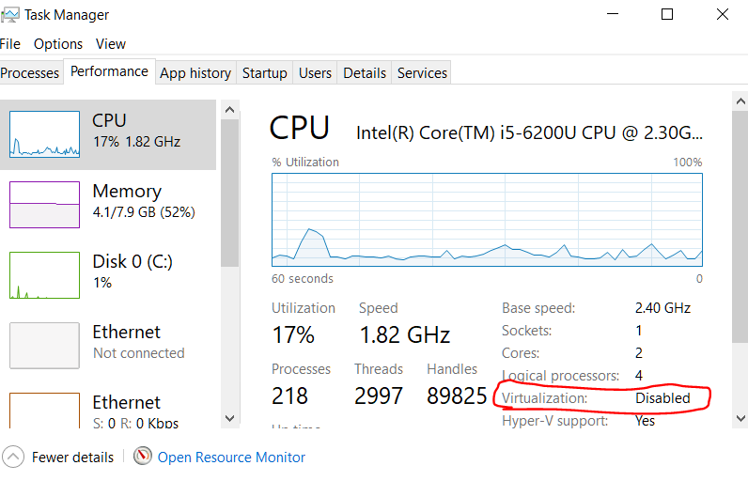

1. Enable Virtualization. (Follow as in <https://www.tutorialspoint.com/windows10/windows10_virtualization.htm> )

Restart your system and enter into BIOS setup. Enable Virtualization, save and exit from BIOS setup. System will restart and docker will be running.

1. Sign-in to your Docker using your docker account.